Deliverable #5: Service-Oriented Software Engineering

1. Service Engineering Application

1.1 Service Candidate Identification
- Inventory Service (Inventory Management)
Justifications for Selection:
The Inventory Service maintains the ground truth for product catalogs and stock levels. It encapsulates operations like increasing or decreasing stock, monitoring reorder thresholds, and handling supplier relationships (e.g., using adapters to fetch supplier data from external ERP systems). It employs the Observer pattern (InventoryEventManager) to broadcast stock-change events across the system, ensuring that other services (like Alerts or Order Fulfillment) can react instantly to inventory changes without needing direct dependencies.
Service Classification:
Business Service (It manages core enterprise resources and supplier logistics).
- Order Service (Order Management)
Justifications for Selection:
The Order Service is central to the CRM's revenue-generating operations. It is responsible for the entire lifecycle of an order—from creation and adding order items (including using custom iterators like HVOrderitem for high-value items) to recalculating totals and attaching delivery details. It acts as a major integration point, often coordinating with the Payment Service and Inventory Service through the OrderFulfillment mediator to ensure smooth checkouts without creating tight coupling between those domains.
Service Classification:
Business Service (It directly handles the core, revenue-driving business transactions of the enterprise).

1.2 Service Requirements Specification
Service 1: Inventory Service
Functional Requirements:
- Catalog Management: Add, update, retrieve, and delete product catalog information.
- Stock Management: Adjust (increase or decrease) stock levels for specific products accurately.
- Threshold Monitoring: Monitor stock against predefined reorder thresholds and trigger alerts when stock is low.
- Supplier Integration: Fetch and synchronize supplier data and purchase orders from external ERP systems using Adapter patterns.
- Event Broadcasting: Publish stock-change events via an InventoryEventManager (Observer pattern) so dependent services (Alerts, Order Fulfillment) are notified asynchronously.
Non-functional Requirements:
- Availability: High availability (e.g., 99.99% uptime) is critical since the Order Service relies on it for stock validation.
- Concurrency & Consistency: Must handle concurrent stock deduction requests safely to prevent race conditions and overselling (e.g., using optimistic locking or database row locks).
- Performance: Low-latency responses for stock-check queries during checkout.
- Resilience: The ERP adapter must handle third-party downtime gracefully without crashing the core inventory system (using circuit breakers/retries).
Inputs, Outputs, and Constraints:
- Inputs: Product creation payloads, stock adjustment requests (increment/decrement), sync triggers for external ERPs.
- Outputs: Product details, real-time stock availability, and asynchronous stock-change events (e.g., published to a message broker like Kafka/RabbitMQ).
- Constraints: Ground truth for inventory must be isolated to this service. External integrations (ERP) are limited by the external system's API rate limits.
Service 2: Order Service
Functional Requirements:
- Lifecycle Management: Handle the complete order lifecycle (Creation, Pending Payment, Processing, Shipped, Delivered).
- Order Item Management: Add, remove, or modify items within an order, utilizing specialized logic (like custom iterators for HVOrderitem for high-value goods).
- Pricing & Calculation: Dynamically recalculate order totals, applying taxes, shipping fees, and relevant discounts.
- Service Coordination: Interface with the OrderFulfillment mediator to coordinate operations with the Payment Service and Inventory Service.
- Delivery Details: Attach and update delivery details for the finalized order.
Non-functional Requirements:
- Reliability: Guaranteed persistence of order states; no dropped or lost orders during system failures.
- Traceability: Maintain a strict audit log of all order state transitions.
- Scalability: Must be able to scale out rapidly to handle sudden spikes in traffic (e.g., holiday sales).
- Security: Ensure customer data and order details are transmitted and stored securely, complying with PII regulations.
Inputs, Outputs, and Constraints:
- Inputs: Customer ID, cart items (product IDs and quantities), shipping addresses, and checkout initiation triggers.
- Outputs: Order confirmation numbers, order status details, and coordination commands sent to the OrderFulfillment mediator.
- Constraints: The service must not directly call Payment or Inventory services, strictly adhering to the mediator pattern to prevent tight coupling. Must handle distributed transaction failures (e.g., implementing Saga pattern rollbacks if payment fails after stock is reserved).
outputs, and constraints.

1.3 Service Interface Design

Inventory Service API (/api/v1/inventory)
HTTP Method | Endpoint | Description | Request Format (JSON) | Response Format (JSON)
GET | /products | Retrieve a list of products (supports pagination & filtering). | N/A | [{ "id": "P1", "name": "Item", "stock": 10 }]
GET | /products/{id} | Get detailed information for a specific product. | N/A | { "id": "P1", "name": "...", "stock": 10 }
POST | /products | Create a new product in the catalog. | { "name": "Item", "sku": "...", "basePrice": 100 } | 201 Created + Product details
PUT | /products/{id} | Fully update a product's details. | { "name": "New Name", "basePrice": 120 } | 200 OK + Updated details
PATCH | /products/{id}/stock | Adjust stock levels (triggers Observer events). | { "adjustment": -2, "reason": "ORDER_ALLOCATED", "referenceId": "O-123" } | { "id": "P1", "currentStock": 8 }
POST | /suppliers/sync | Trigger the Adapter to fetch latest data from external ERP. | N/A | 202 Accepted { "jobId": "sync-456", "status": "PENDING" }

1.1 Inventory Service Endpoint Details

1. Retrieve Products

Endpoint: GET /api/v1/inventory/products

Description:
Retrieves a list of products from the inventory catalog. This endpoint may support pagination and filtering by product name, SKU, stock status, or category.

Request Format:
N/A

Sample Response:

[

{

"id": "P1",

"name": "Item",

"stock": 10

}

]

2. Retrieve Product by ID

Endpoint: GET /api/v1/inventory/products/{id}

Description:
Retrieves detailed information for a specific product using its product ID.

Request Format:
N/A

Sample Response:

{

"id": "P1",

"name": "Item",

"stock": 10

}

3. Create Product

Endpoint: POST /api/v1/inventory/products

Description:
Creates a new product in the inventory catalog.

Request Format:

{

"name": "Item",

"sku": "SKU-001",

"basePrice": 100

}

Response Format:

{

"id": "P1",

"name": "Item",

"sku": "SKU-001",

"basePrice": 100,

"stock": 0

}

Status Code: 201 Created

4. Update Product

Endpoint: PUT /api/v1/inventory/products/{id}

Description:
Fully updates an existing product’s information.

Request Format:

{

"name": "New Name",

"basePrice": 120

}

Response Format:

{

"id": "P1",

"name": "New Name",

"basePrice": 120,

"stock": 10

}

Status Code: 200 OK

5. Adjust Product Stock

Endpoint: PATCH /api/v1/inventory/products/{id}/stock

Description:
Adjusts the stock quantity of a product. This endpoint is used when stock is increased, decreased, allocated to an order, or returned. A stock adjustment may trigger observer events such as low-stock alerts or supplier reorder actions.

Request Format:

{

"adjustment": -2,

"reason": "ORDER_ALLOCATED",

"referenceId": "O-123"

}

Response Format:

{

"id": "P1",

"currentStock": 8

}

Status Code: 200 OK

6. Sync Suppliers

Endpoint: POST /api/v1/inventory/suppliers/sync

Description:
Triggers the supplier adapter to fetch the latest supplier data from the external ERP system.

Request Format:
N/A

Response Format:

{

"jobId": "sync-456",

"status": "PENDING"

}

Status Code: 202 Accepted

2. Order Service API (/api/v1/orders)
HTTP Method | Endpoint | Description | Request Format (JSON) | Response Format (JSON)
POST | / | Create a new, empty order or an order with initial items. | { "customerId": "C-999", "items": [...] } | 201 Created { "orderId": "O-123", "status": "DRAFT", "total": 0 }
GET | /{id} | Retrieve full details of a specific order. | N/A | { "orderId": "O-123", "status": "DRAFT", "items": [...] }
POST | /{id}/items | Add an item to the order (handles custom types like HVOrderItem). | { "productId": "P1", "quantity": 1, "isHighValue": true } | 200 OK + Recalculated Order
DELETE | /{id}/items/{itemId} | Remove a specific item from the order. | N/A | 200 OK + Recalculated Order
PUT | /{id}/delivery | Attach or update delivery and shipping details. | { "address": "123 Main St", "method": "EXPRESS" } | 200 OK
POST | /{id}/checkout | Initiates the checkout process via OrderFulfillment mediator. | { "paymentMethodId": "PM-444" } | 202 Accepted { "orderId": "O-123", "status": "PROCESSING" }
PATCH | /{id}/status | Internal endpoint to update order status (e.g., after mediator finishes). | { "status": "COMPLETED", "note": "Payment successful" } | 200 OK

2.1 Order Service Endpoint Details

1. Create Order
Endpoint: POST /api/v1/orders/
Description:
Creates a new empty order or an order with initial items for a specific customer.
Request Format:
{
"customerId": "C-999",
"items": [
{
"productId": "P1",
"quantity": 2
}
]
}
Response Format:
{
"orderId": "O-123",
"status": "DRAFT",
"total": 0
}
Status Code: 201 Created

2. Retrieve Order by ID
Endpoint: GET /api/v1/orders/{id}
Description:
Retrieves the full details of a specific order, including order status, items, total amount, payment status, and delivery information.
Request Format:
N/A
Response Format:
{
"orderId": "O-123",
"status": "DRAFT",
"items": [
{
"itemId": "OI-1",
"productId": "P1",
"quantity": 1,
"price": 100
}
],
"total": 100
}
Status Code: 200 OK

3. Add Item to Order
Endpoint: POST /api/v1/orders/{id}/items
Description:
Adds an item to an existing order. This endpoint may support custom order item types such as high-value order items.
Request Format:
{
"productId": "P1",
"quantity": 1,
"isHighValue": true
}
Response Format:
{
"orderId": "O-123",
"status": "DRAFT",
"items": [
{
"itemId": "OI-1",
"productId": "P1",
"quantity": 1,
"isHighValue": true
}
],
"total": 100
}
Status Code: 200 OK

4. Remove Item from Order
Endpoint: DELETE /api/v1/orders/{id}/items/{itemId}
Description:
Removes a selected item from an existing order and recalculates the order total.
Request Format:
N/A
Response Format:
{
"orderId": "O-123",
"status": "DRAFT",
"items": [],
"total": 0
}
Status Code: 200 OK

5. Attach or Update Delivery Details
Endpoint: PUT /api/v1/orders/{id}/delivery
Description:
Attaches or updates delivery and shipping details for an order.
Request Format:
{
"address": "123 Main St",
"method": "EXPRESS"
}
Response Format:
{
"orderId": "O-123",
"delivery": {
"address": "123 Main St",
"method": "EXPRESS"
}
}
Status Code: 200 OK

6. Checkout Order
Endpoint: POST /api/v1/orders/{id}/checkout
Description:
Initiates the checkout process using the OrderFulfillment mediator. This operation coordinates order processing, inventory allocation, payment handling, delivery attachment, and receipt generation.
Request Format:
{
"paymentMethodId": "PM-444"
}
Response Format:
{
"orderId": "O-123",
"status": "PROCESSING"
}
Status Code: 202 Accepted

7. Update Order Status
Endpoint: PATCH /api/v1/orders/{id}/status
Description:
Updates the order status after checkout, payment processing, or internal workflow completion.
Request Format:
{
"status": "COMPLETED",
"note": "Payment successful"
}
Response Format:
{
"orderId": "O-123",
"status": "COMPLETED",
"note": "Payment successful"
}
Status Code: 200 OK
Notes :

200 OK Request succeeded, usually used for GET, PUT, PATCH, DELETE responses
201 created A new resource was created successfully, usually after POST
202 accepted Request was accepted for processing, but may not be finished yet

2. REST API Implementation
pom.xml: added the Gson dependency to let REST APIs communicate using JSON. Java doesn't understand JSON natively, so Gson acts as a translator to convert our Java objects into JSON text when sending a response, and when receiving a request.
ProductController.java: added a getAllProducts() method. To satisfy the GET /products requirement, we need a method that returns the entire catalog list from the repository.
InventoryApiServer.java & OrderApiServer.java: Refactored the monolithic API architecture into two distinct, domain-specific server classes inside com.crm.api. Using Java's built-in com.sun.net.httpserver.HttpServer, we created two separate web servers running concurrently on different ports (InventoryApiServer on port 8080 and OrderApiServer on port 8081). They listen for incoming HTTP requests and independently route them to the correct Controller methods, successfully achieving service separation.
Main.java:added com.crm.api.ApiServer.start(...) into the main method. The system needs to start listening for API web requests automatically when the application boots up, running in the background behind the interactive console.

2.1 GET and POST APIs Implementation
- GET API 1: Retrieve All Products
Endpoint: GET /api/v1/inventory/products
Implementation Details: Handled by the ProductHandler inside the ApiServer. It invokes productController.getAllProducts() to fetch the entire catalog from the repository and uses the Gson library to serialize the Java Collection into a JSON array response.
Status Code: 200 OK
- GET API 2: Retrieve Specific Product
Endpoint: GET /api/v1/inventory/products/{id}
Implementation Details: The ProductHandler parses the requested ID from the URL path and queries the productController. If the product exists, it returns a serialized JSON object of the product. If it does not exist, it securely returns a 404 Not Found JSON error.
Status Code: 200 OK (or 404 Not Found)
- POST API 1: Create a New Product
Endpoint: POST /api/v1/inventory/products
Implementation Details: The server reads the incoming HttpExchange request body stream as UTF-8 JSON. It deserializes the payload into a ProductRequest Data Transfer Object (DTO). It then instantiates a new Product entity with an auto-generated timestamp ID and saves it via the productController.
Status Code: 201 Created
- POST API 2: Create a New Order
Endpoint: POST /api/v1/orders
Implementation Details: Handled by the OrderHandler. It captures the incoming JSON payload containing a customerId. It generates a unique Order ID and instantiates a new Order object mapped to that customer. It also dynamically parses an optional array of items in the payload, looks up real product details from the ProductController, and instantly attaches the order items to the new order
Status Code: 201 Created

2.2 PUT and DELETE APIs Implementation
PUT API 1: Fully Update a Product
Endpoint: PUT /api/v1/inventory/products/{id}
Implementation Details:
Handled by the ProductHandler inside the ApiServer. It parses the requested ID from the URL path. If the product exists, it reads the incoming JSON payload into a ProductUpdateRequest DTO, dynamically updates the product's name, base price, description, and supplier ID , saves it via the productController, and returns the serialized JSON of the updated product. Status Code: 200 OK (or 404 Not Found, 400 Bad Request)
PUT API 2: Attach Delivery Details to Order
Endpoint: PUT /api/v1/orders/{id}/delivery
Implementation Details: Handled by the OrderHandler inside the ApiServer. It parses the requested order ID from the URL path. If the order exists, it reads the JSON payload into a DeliveryRequest DTO, constructs a new Delivery object containing the provided address, and invokes orderController.attachDelivery() to associate it with the order before returning the recalculated JSON order. Status Code: 200 OK (or 404 Not Found, 400 Bad Request)
DELETE API 1: Remove an Item from an Order
Endpoint: DELETE /api/v1/orders/{id}/items/{itemId}
Implementation Details: Handled by the OrderHandler inside the ApiServer. It extracts both the order ID and the item ID from the URL path. If the order exists, it delegates to orderController.removeItem() to safely delete the line item from the order list and update the total amount, then responds with the updated order in JSON format. Status Code: 200 OK (or 404 Not Found)
DELETE API 2: Delete a Product
Endpoint: DELETE /api/v1/inventory/products/{id}
Implementation Details:
Handled by the ProductHandler inside the ApiServer. It parses the requested ID from the URL path and queries the productController. If the product is found, it invokes productController.deleteProduct() to permanently remove the product from the catalog repository and securely returns a JSON success message. Status Code: 200 OK (or 404 Not Found)

3. Service Composition
Composite Service Description
The Checkout Orchestrator is a high-level Composite Service (Business Service) designed to encapsulate the complex logic required to transition a shopping cart into a fulfilled order. Following the SOA (Service-Oriented Architecture) Composition Pattern, this service does not own its own data; instead, it coordinates interactions between four downstream "Entity" or "Utility" services: Inventory, Order, Payment, and Communication.

Architecturally, it serves as a Facade for the client, masking the underlying complexity of the micro-operations. By exposing a single `POST /api/v1/composite/place-order` endpoint, it ensures that business rules—such as "never deduct stock unless payment is verified"—are enforced centrally on the server side. This provides a clean separation of concerns: domain services focus on CRUD operations, while the Composite Service focuses on the Business Process Management (BPM) and transactional integrity.

Composite Service Workflow
The internal logic follows a strictly sequenced execution path to ensure atomicity and data consistency across the distributed system components:
1. Input Sanitation & Preliminary Stock Validation:
The orchestrator parses the `CheckoutRequest` and performs a synchronous "Read-Only" call to the Inventory Service. It verifies that each `productId` exists and that the `stockQuantity` satisfies the requested amount. If validation fails, the process terminates immediately with a `400 Bad Request`.
2. Order Registration & State Initialization
The orchestrator communicates with the Order Service to persist a new `Order` record in a `Pending` state.It attaches all `OrderItems` to the record, calculating the final `totalAmount` which will be used for the subsequent payment step.

3. Financial Transaction Execution
The orchestrator initiates a call to the Payment Service . It passes the total amount and the chosen `PaymentMethod` (e.g., Credit Card).The workflow waits for the Authorization and Capture response from the external payment gateway.
4. Transactional Commitment & Stock Deduction
Success Path: If payment is successful, the orchestrator issues a "Write" command to the Inventory Service to permanently decrement the stock. It then updates the Order Service record to `Processing` status.
Compensation Path: If payment fails, the orchestrator triggers a "Cancel" command on the Order Service record. No inventory is deducted, ensuring the system returns to its original consistent state (Rollback-like behavior).
5. Multi-Channel Notification Dispatch
Upon successful completion, the orchestrator invokes the Communication Service to generate and send a customer receipt via the configured channel (Email or SMS).
Benefits of this Composition:
Transactional Consistency (Atomicity): Prevents partial failures where an order is placed but inventory is not updated.
Performance Optimization: Minimizes "chattiness" over the network by consolidating multiple service calls into a single client-facing transaction.
Business Agility: New steps (like loyalty point calculation or fraud checks) can be added to the workflow without modifying the core domain services.

4. API Documentation (OpenAPI)
In the code files named openapi.yaml

5 Testing
Provide screenshots from Postman and sample requests/responses for the implemented APIs.
OrderService:
- GET API Testing:
- Retrieve a Specific Order:
Expected Response 200:
{
"orderId": "ORD-001",
"customerId": "CUST-001",
"createdAt": "2026-05-16T10:18:58.5852968",
"lastUpdatedAt": "2026-05-16T10:18:58.5868056",
"status": "Processing",
"items": [
{
"orderItemId": "ITM-001",
"productId": "PROD-01",
"productName": "Wireless Mouse",
"quantity": 2,
"unitPrice": {
"amount": 149.99,
"currency": "EGP"
},
"subtotal": {
"amount": 299.98,
"currency": "EGP"
}
},
{
"orderItemId": "ITM-002",
"productId": "PROD-02",
"productName": "Wireless Keyboard",
"quantity": 1,
"unitPrice": {
"amount": 299.99,
"currency": "EGP"
},
"subtotal": {
"amount": 299.99,
"currency": "EGP"
}
}
],
"totalAmount": {
"amount": 599.97,
"currency": "EGP"
},
"paymentId": "TXN-001"
}
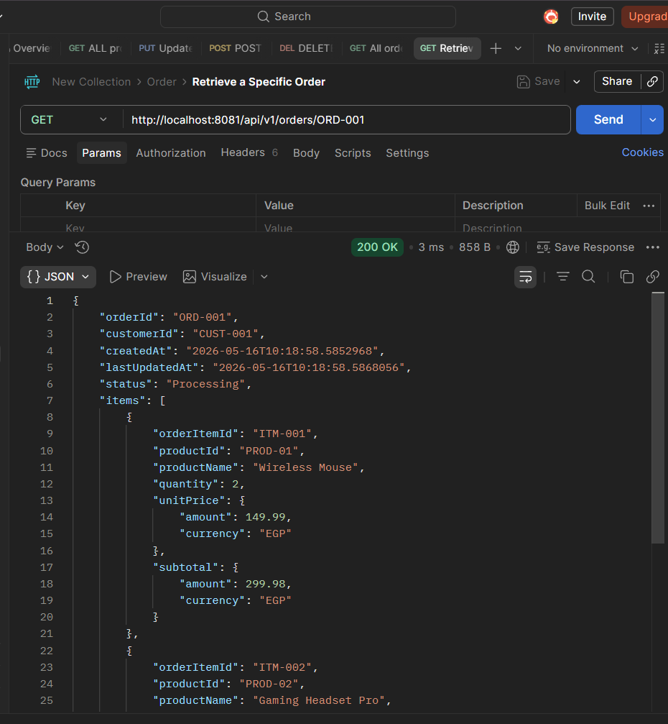

- POST API Testing:
Create a New Order with Items (POST):
Request Body (Raw JSON):
{
"customerId": "CUST-001",
"items": [
{
"productId": "PROD-01",
"quantity": 2,
"priceAmount": 149.99,
"priceCurrency": "EGP"
}
]
}
Expected Response (201 Created):
{
"orderId": "ORD-100",
"customerId": "CUST-001",
"createdAt": "2026-05-15T10:00:00.000",
"lastUpdatedAt": "2026-05-15T10:00:00.000",
"status": "Pending",
"items": [
{
"orderItemId": "ORD-100-ITEM-1",
"productId": "PROD-01",
"productName": "Wireless Mouse",
"quantity": 2,
"unitPrice": {
"amount": 149.99,
"currency": "EGP"
},
"subtotal": {
"amount": 299.98,
"currency": "EGP"
}
}
],
"totalAmount": {
"amount": 299.98,
"currency": "EGP"
}
}
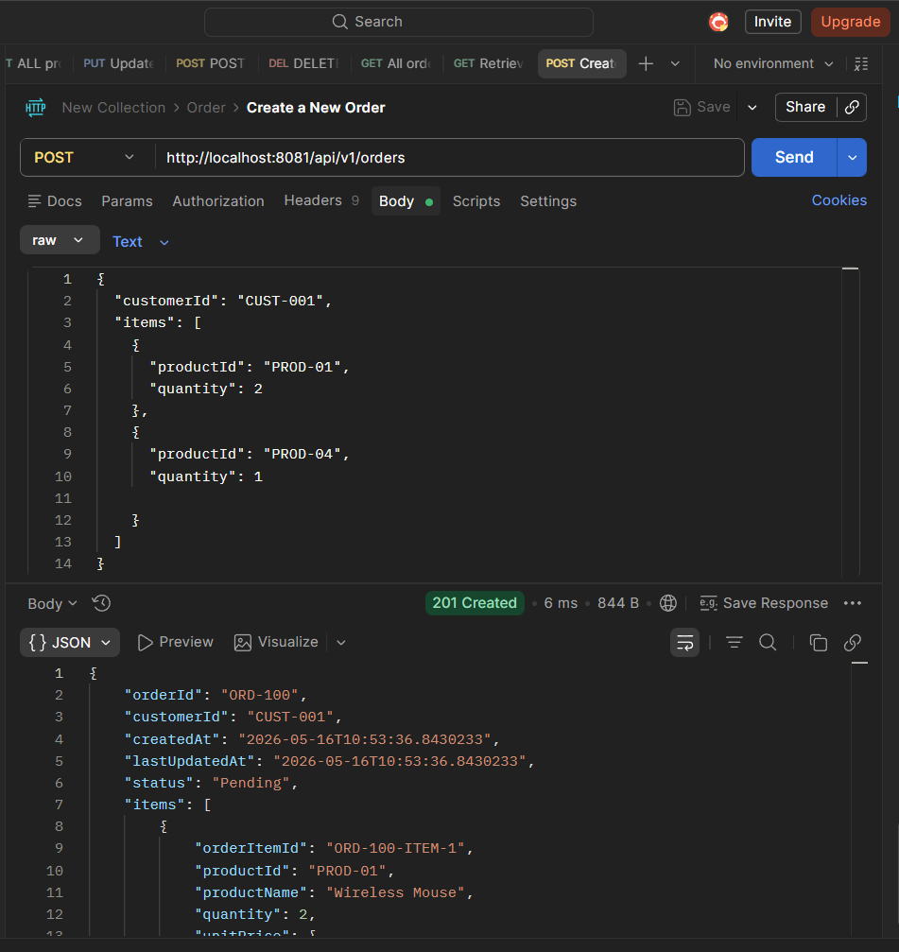

- PUT API Testing:
Update Order Delivery Address (PUT):
Request Body (Raw JSON):
{
"address": "15 Main St, Cairo, Egypt"
}
Expected Response (200 OK):
{
"orderId": "ORD-100",
"customerId": "CUST-001",
"status": "Pending",
"delivery": {
"deliveryId": "DEL-1685458392",
"orderId": "ORD-100",
"deliveryAddress": {
"street": "15 Main St",
"city": "Cairo",
"zone": "Egypt"
},
"estimatedDeliveryDate": "2026-05-18T10:00:00.000",
"status": "Scheduled"
},
"items": [ ... ],
"totalAmount": { ... }
}

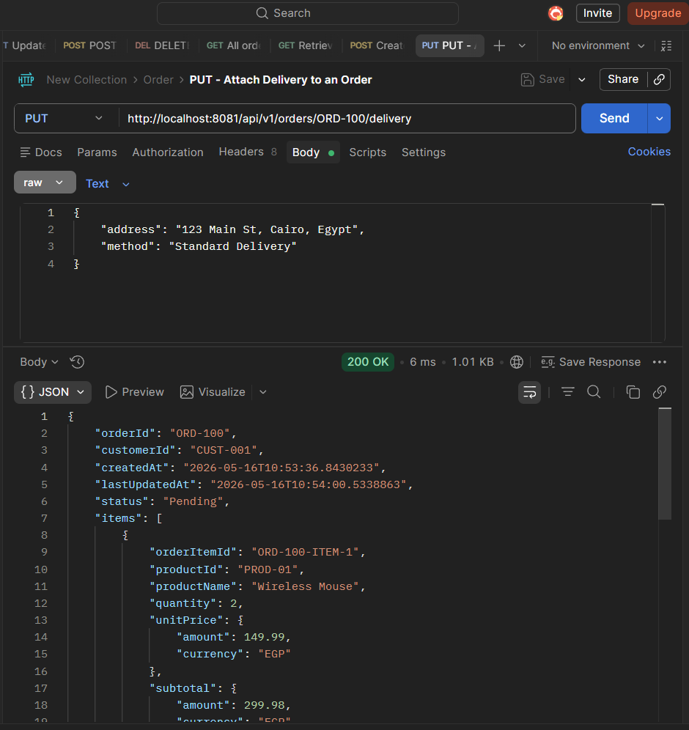

- DELETE API Testing:

Remove Item from Order (DELETE)
Expected Response (200 OK): (Returns the updated order object without the deleted item)
{
"orderId": "ORD-100",
"customerId": "CUST-001",
"status": "Pending",
"items": [],
"totalAmount": null
}

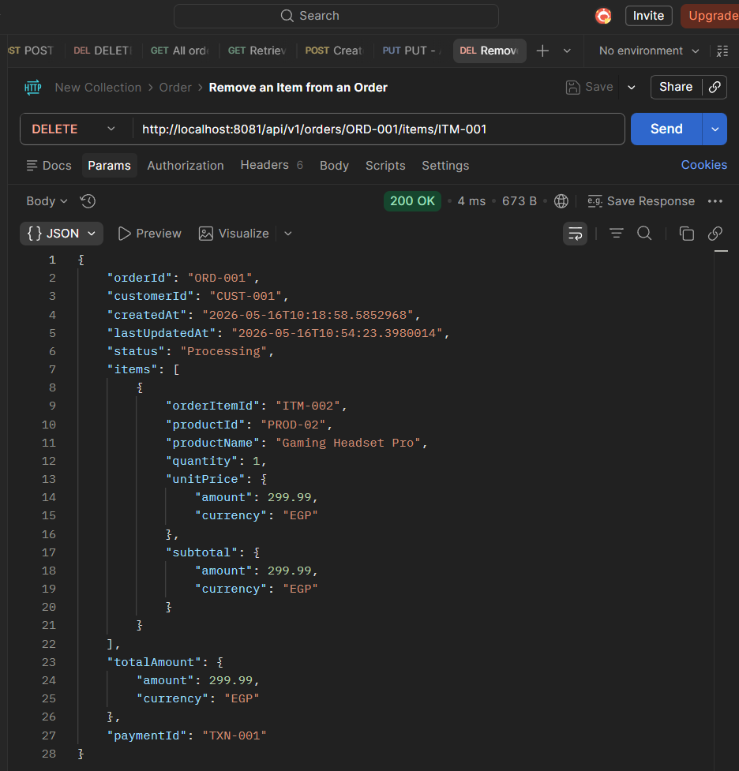

Inventory Service:
- GET API Testing:
- All Products:
Expected Response (200 OK):
[
{
"productId": "PROD-01",
"name": "Wireless Mouse",
"description": "Ergonomic wireless mouse",
"unitPrice": {
"amount": 149.99,
"currency": "EGP"
},
"stockQuantity": 20,
"supplierId": "SUP-01"
},
{
"productId": "PROD-100",
"name": "Wireless Mechanical Keyboard",
"description": "RGB backlight, hot-swappable switches",
"unitPrice": {
"amount": 129.5,
"currency": "USD"
},
"stockQuantity": 50,
"supplierId": "SUP-01"
}
]

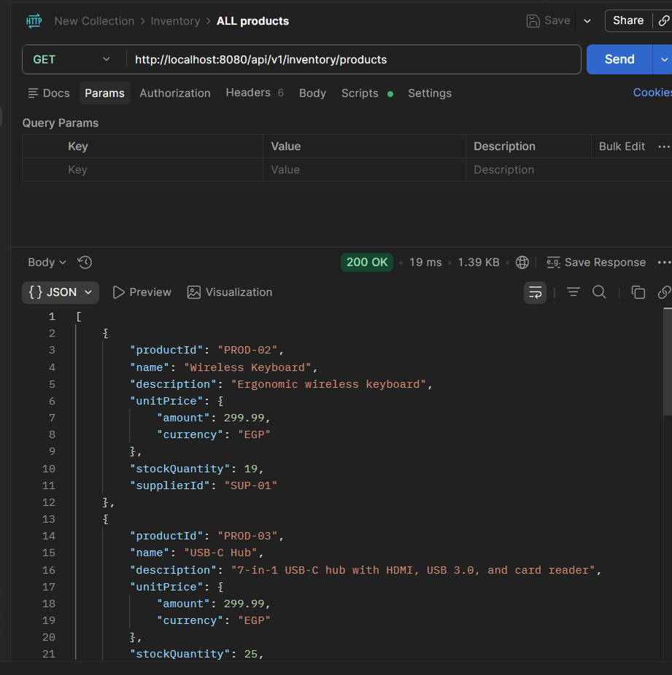

- POST API Testing:
- Create a New Product (POST):
Request Body (Raw JSON):
{
"name": "Wireless Mechanical Keyboard",
"description": "RGB backlight, hot-swappable switches",
"priceAmount": 129.50,
"priceCurrency": "USD",
"stockQuantity": 50,
"supplierId": "SUP-01"
}
Expected Response (201 Created):
{
"productId": "PROD-100",
"name": "Wireless Mechanical Keyboard",
"description": "RGB backlight, hot-swappable switches",
"unitPrice": {
"amount": 129.5,
"currency": "USD"
},
"stockQuantity": 50,
"supplierId": "SUP-01"
}
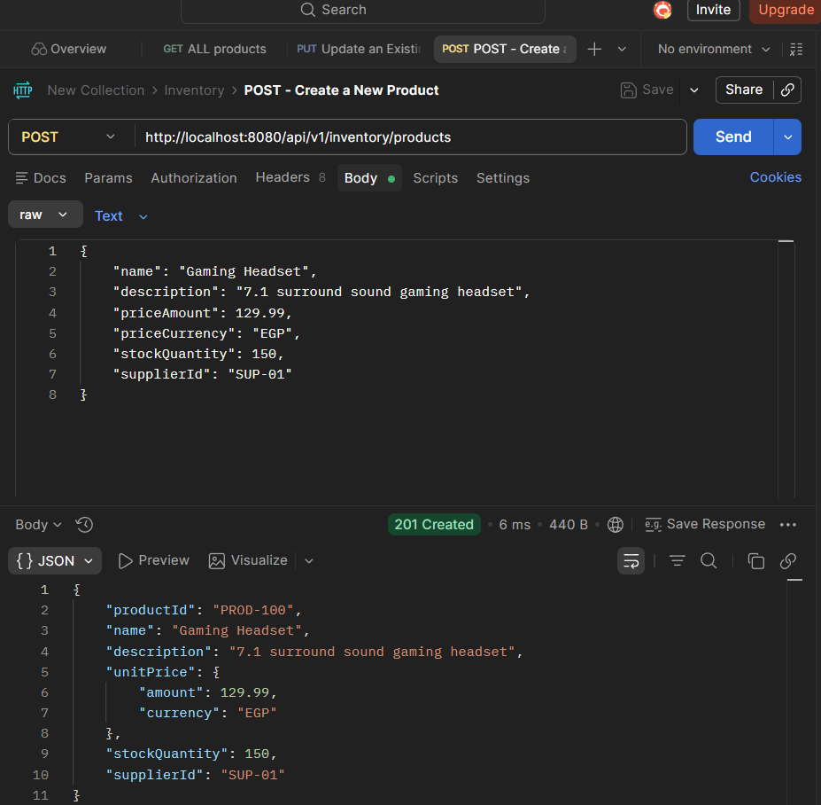

- PUT API Testing:
Update a Product:
Request Body (Raw JSON):
{
"name": "Wireless Mechanical Keyboard v2",
"basePrice": 115.00,
"description": "Updated model with better battery",
"supplierId": "SUP-02"
}
Expected Response (200 OK):
{
"productId": "PROD-100",
"name": "Wireless Mechanical Keyboard v2",
"description": "Updated model with better battery",
"unitPrice": {
"amount": 115.0,
"currency": "USD"
},
"stockQuantity": 50,
"supplierId": "SUP-02"
}

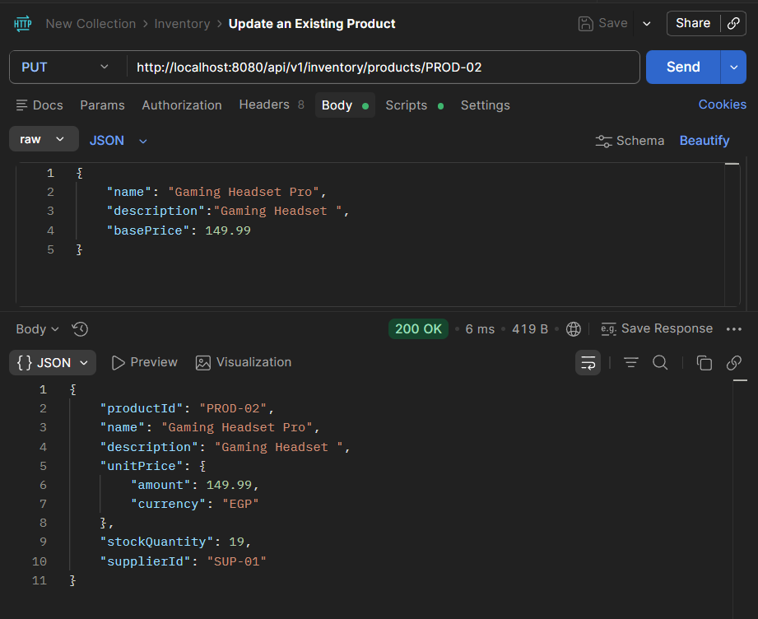

- DELETE API Testing:
Delete a Product
Expected Response (200 OK): (Empty response body with HTTP 200 OK status code)
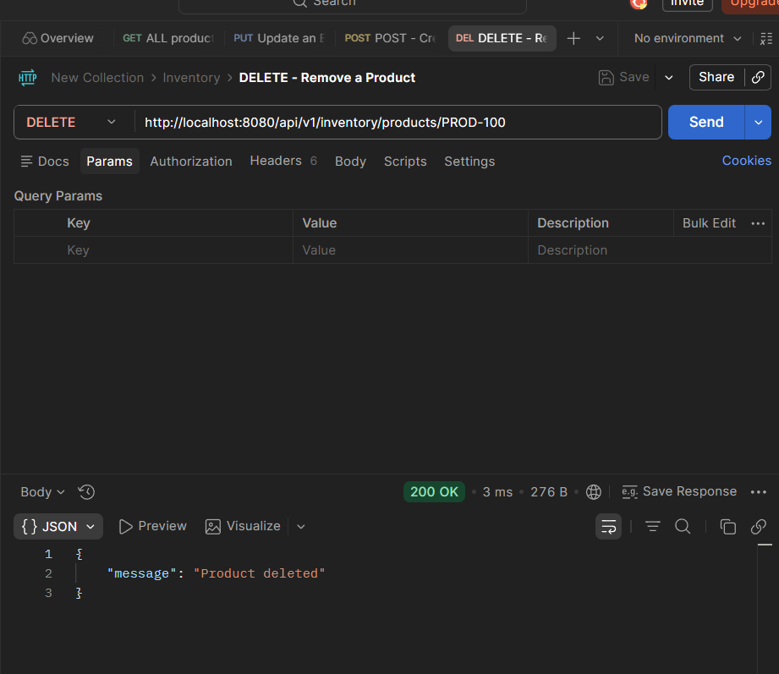

Composite Service testing:
Expected Request:
{
"customerId": "CUST-001",
"items": [
{
"productId": "PROD-01",
"quantity": 1
},
{
"productId": "PROD-02",
"quantity": 2
}
],
"paymentMethod": "Card"
}

Expected Response 201:
{
"orderId": "ORD-COMP-500",
"status": "Completed",
"total": 749.97,
"currency": "EGP"
}

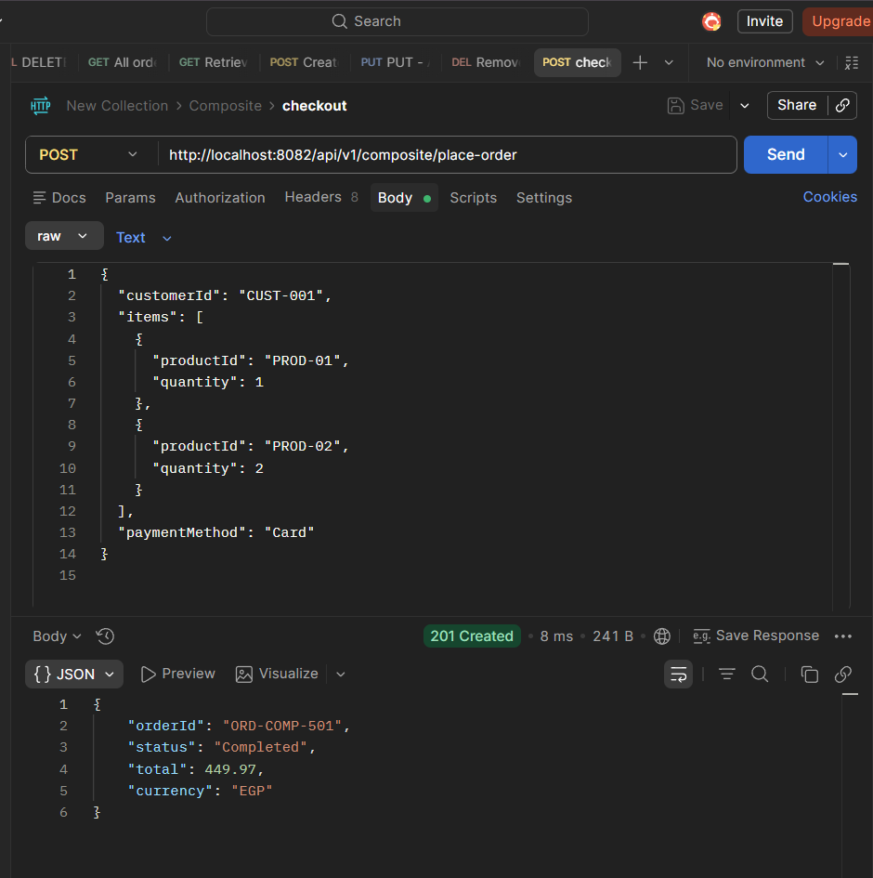

In cli:
[Composite Service] Orchestrating checkout for customer: CUST-001
Processing Card payment for Order: ORD-COMP-501
[Payment] Amount validated: 449.97 EGP
[CardProcessor] Authorising credit card charge of 449.97 EGP...
[CardProcessor] Authorisation approved.
[CardProcessor] Capturing funds: 449.97 EGP settled.
=== CARD PAYMENT RECEIPT ===
Transaction ID: TXN-1778918201599
Amount Paid: 449.97 EGP
Method: Credit Card
Status: APPROVED
============================
Payment saved in database
Stock change detected for product 'PROD-01' ? new quantity: 18. Creating low-stock alert.
Alert Saved to database
LowStockAlert -> notify inventory for product PROD-01
Auto-syncing warehouse:Main Warehouse Decreasing record REC-001 by 1
Stock change detected for product 'PROD-02' ? new quantity: 17. Creating low-stock alert.
Alert Saved to database
LowStockAlert -> notify inventory for product PROD-02
Auto-syncing warehouse:Main Warehouse Decreasing record REC-002 by 2
Email to customer@example.com: Success! Your order ORD-COMP-501 has been placed and paid.

